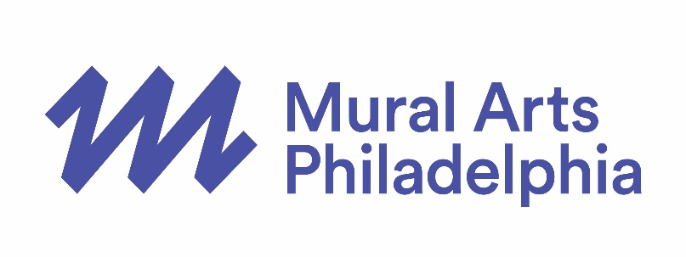

PRESS CONTACT:
Cari Feiler Bender, Relief Communications, LLC
610-416-1216 or cari@reliefcomm.com

MURAL ARTS PHILADELPHIA ANNOUNCES RADIO SILENCE
NEW LIVE RADIO SHOW AND SERIES BY MICHAEL RAKOWITZ

Tweet this: Radio Silence by artist Michael Rakowitz announced by @MuralArts - live performance & radio series July 2017 bit.ly/MAPRadioSilence

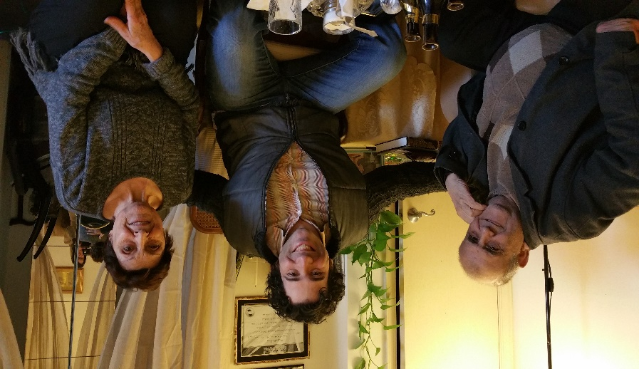
PHILADELPHIA – March 13, 2017 - Mural Arts Philadelphia announces a new project by artist Michael Rakowitz, entitled Radio Silence, curated by Elizabeth Thomas. On July 29, 2017, Rakowitz and Mural Arts Philadelphia will launch a 10-episode radio broadcast, kickstarted by a large-scale performance on Independence Mall in Historic Philadelphia. Radio Silence, conceived specifically for Philadelphia, the birthplace of American democracy, was inspired by famed Iraqi broadcaster Bahjat Abdulwahed, who lived in Philadelphia as a refugee until his death last year. The project interweaves dreams and memories from Iraq, America, and in-between into a soundscape of the contemporary refugee experience. It brings together recordings of Abdulwahed with other Philadelphia-based Iraqi refugees and Iraq War veterans working with local non-profit Warrior Writers, as well as Iraqi musicians and other performers, all of whom will share their experiences as part of the Iraqi diaspora, and the culture of an Iraq, that due to war and political unrest, no longer exists. Using first-person narrative, poetry, and music, in English and Arabic, Radio Silence reconstructs a timeline of remembrances spanning the culturally rich Iraq of the 1960s to the decimation of physical and emotional landscapes during and after the war. Following the one-time stage production, staged on Independence Mall and simulcast on PhillyCAM TV, a special 10-episode radio show will air on WPPM PhillyCAM Radio 106.5 FM and community radio stations across the country in partnership with Prometheus Radio Project and distributed nationwide through Public Radio Exchange (PRX). A website for Radio Silence will host episodes for download as well as archival images and research, resources, and essays by leading practitioners on performance, Iraqi culture and music, and contemporary visual art designed by Ryan Hines.
Bahjat Abdulwahed, Michael Rakowitz, and Hayfaa Ibrahem Abdulqader. Photo courtesy of Michael Rakowitz.

Mural Arts Philadelphia has been connecting communities through public art for more than 30 years. As an extension of that work, Mural Arts and Rakowitz are providing a new mechanism to connect and build trust between two vastly different vulnerable and resilient communities – Iraqi refugees and American Iraq War veterans – who might not otherwise have a way to talk to each other. Radio Silence is a further evolution of muralism in the 21st century, affecting social change and connecting communities through public art, while placing the experiences and talents of citizens into public space – in this case, on public airwaves instead of street corners. For audio clips and high resolution images, go to the press room at bit.ly/MAPRadioSilencePress.

Jane Golden, Executive Director of Mural Arts Philadelphia, said “Mural Arts Philadelphia is excited to work with renowned and politically-engaged artist Michael Rakowitz, and also to expand beyond the visual arts to effect impactful public change.”

Radio Silence is about the destruction of culture due to wartime violence and displacement, opening a door to an Iraq of the past that has largely been forgotten. It is a story of a lost country’s diaspora to America, where shared history brings people together. And it is a story of how waves of immigration have brought tastes and customs from other cultures, influenced American life, and changed it forever.

July 29 Live Radio Performance
Rakowitz is a Chicago-based artist who created Radio Silence for Philadelphia, where
many immigrants have come to America over time. He chose to stage the live show on Independence Mall because it is the symbolic home of American democracy and a site of heightened significance during our current moment in history, when issues around immigration are in the spotlight and receiving wide attention. The public and free live performance on July 29 includes Rakowitz as the host along with performances and storytelling by members of the local Iraqi refugee community, a special “house band” ensemble of virtuoso musicians in the Arab tradition led by Hanna Khoury, music director of Al-Bustan Seeds of Culture, plus animal performers drawn from Iraqi tradition, and Iraqi cooking demonstrations. The stage performance concludes with music and food from the only Iraqi restaurant in Philadelphia, Amasi Restaurant and Hookah, located in North Philadelphia. The stage is designed by Philadelphia-based, Iraqi-born architect and painter Mayaddah Alhumssi, as an homage to the famous Iraqi monument, the Ziggurat of Ur. The stage’s backdrop will be based on a painting by Alhumssi, which brings in other symbolic motifs from Iraqi culture, all to be seen with the American monument of Independence Hall in the background.

Radio Show 10 Episodes
The 10-part radio show, to be rolled out in 30-minute weekly episodes beginning Sunday, August 6 (see website for individual station listings across the country), includes themes such as secrets, shyness, silent letters, censorship, dead air, and peace. Radio Silence is hosted by Rakowitz and features recordings of Bahjat Abdulwahed, plus interviews with his wife and a number of other Iraqi refugees living in the Philadelphia area. Rakowitz and Thomas also conducted a series of workshops and recordings with Warrior Writers, creating poetry and songs and capturing stories of American veterans who served in Iraq. By weaving these two perspectives together, Radio Silence revives ghosts of days gone by and humanizes both sides of a new American story. More information about Mural Arts Philadelphia’s Radio Silence can be found at radiosilence.muralarts.org.

Major support for Radio Silence has been provided by The Pew Center for Arts & Heritage with additional support from the National Endowment for the Arts and the Hummingbird Foundation. Project collaborators and partners include agencies and nonprofits working on refugee and veteran issues, and independent community-driven media nonprofits.

About the Curator and Artist
Elizabeth Thomas, curator for Radio Silence stated, “Radio Silence reflects on global issues of migration, war, identity, and culture – conceived to reach a national and international audience – but was born out of a deep connection to Philadelphia’s history and its present day. Rakowitz was inspired by Philadelphia’s role in the founding of American democracy to engage with questions of American democracy today – namely who are we as Americans, what immigrants bring to this country and what they leave behind in their home countries, and how we as citizens are impacted by the decisions made by our government.”
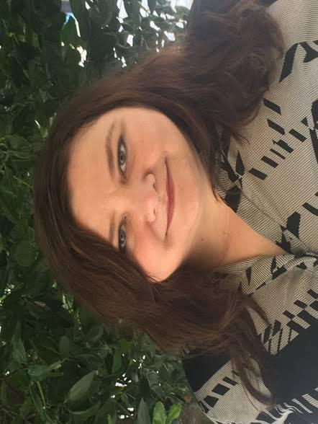
Thomas is the Director of Public Engagement for the Fine Arts Museums of San Francisco, and a Senior Lecturer in Curatorial Practice at California College of the Arts. She began her work with the Radio Silence project while curator-in-residence with Mural Arts Philadelphia. Her work focuses on research-based commissions with artists in museum and public contexts, with curatorial positions at Carnegie Museum of Art and Walker Art Center. As curator of the MATRIX program at UC Berkeley Art Museum she initiated projects with artists such as Omer Fast, Futurefarmers, Emily Roysdon, Jill Magid, Trevor Paglen, Allison Smith, Ahmet Ogut, and Tomas Saraceno.

Michael Rakowitz is an Iraqi-American artist living and working in Chicago. His work has appeared in venues worldwide including dOCUMENTA (13), MoMA, MassMOCA, 16th Biennale of Sydney, 10th and 14th Istanbul Biennials, Sharjah Biennial 8, National Design Triennial at the Cooper-Hewitt, and Transmediale 05. He has had solo exhibitions at Tate Modern in London, Alberto Peola Arte Contemporanea in Torino, and Kunstraum Innsbruck. He is the recipient of a 2012 Tiffany Foundation Award, the 2003 Dena
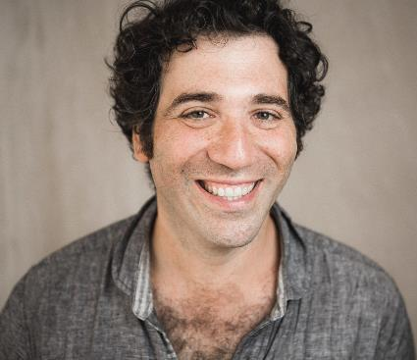
Foundation Award, and the 2002 Design 21 Grand Prix from UNESCO. His work features in major private and public collections including the Museum of Modern Art, New York; Neue Galerie, Kassel, Germany; Van Abbemuseum, Endhoven, Netherlands; The British Museum; The Metropolitan Museum of Art, New York; Kabul National Museum, Afghanistan; and UNESCO, Paris. His solo exhibition, The worst condition is to pass under a sword which is not one’s own was on view at Tate Modern in London in 2010. Rakowitz was commissioned by Creative Time in 2011 for his project, Spoils, a culinary intervention at New York City’s Park Avenue restaurant that invited diners to eat off of plates looted from Saddam Hussein’s palaces. Enemy Kitchen (2003-ongoing) is a food truck serving Iraqi food to Chicago’s hungry public, staffed by veterans of the Iraq War working under Iraqi refugee chefs. His first US museum survey, titled Backstroke of the West, will open at the Museum of Contemporary Art Chicago in September 2017. Rakowitz is Professor of Art Theory and Practice at Northwestern University.
Mural Arts Philadelphia is the nation’s largest public art program, dedicated to the belief that art ignites change. For over 30 years, Mural Arts has united artists and communities through a collaborative and equitable process, creating nearly 4,000 artworks that have transformed public spaces and individual lives. Mural Arts aims to empower people, stimulate dialogue, and build bridges to understanding with projects that attract artists from Philadelphia and around the world, and programs that focus on youth education, restorative justice, mental health and wellness, and public art and its preservation. Popular mural tours offer a firsthand glimpse into the inspiring stories behind Mural Arts’ iconic and unparalleled collection, which has earned Philadelphia worldwide recognition as the “City of Murals.” For more information, call 215-685-0750 or visit muralarts.org. Follow us on social media: @muralarts on Twitter, Instagram, and Snapchat, MuralArtsPhiladelphia on Facebook, and phillymuralarts on YouTube.
###
EDITOR’S NOTE: More about Radio Silence, including audio samples and high-resolution images, are available in the Mural Arts Philadelphia press room at bit.ly/MAPRadioSilencePress.

