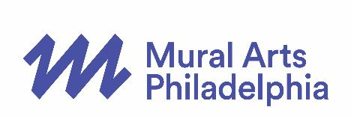
PRESS CONTACT:
Cari Feiler Bender, Relief Communications, LLC
610-416-1216 or cari@reliefcomm.com

MURAL ARTS PHILADELPHIA ANNOUNCES ROSTER OF
OVER 20 ARTISTS IN 10 LOCATIONS FOR MONUMENT LAB
A Citywide Public Art and History Project in Fall 2017

Tweet this: Monument Lab from @muralarts will feature over 20 artists in 10 Philadelphia squares and parks in fall 2017 #monumentlab bit.ly/MAPMLinfo

PHILADELPHIA – February 1, 2017 – Mural Arts Philadelphia announces the roster of over 20 artists, hailing from Philadelphia and from locations around the world, who will create temporary public art in 10 locations across the city for Monument Lab this fall. Monument Lab is a nine-week citywide public art and history project co-produced by Mural Arts Philadelphia and curators Paul Farber, Ken Lum, and A. Will Brown. The exhibition will take place September 16 through November 19, 2017, in the five original William Penn Center City squares as well as five neighborhood parks throughout the City of Philadelphia.
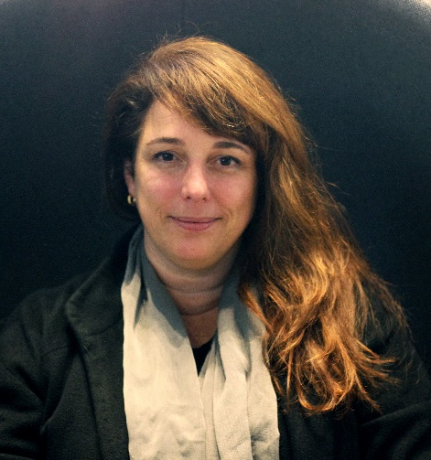
Tania Bruguera
photo by Hugo Huerta Marin

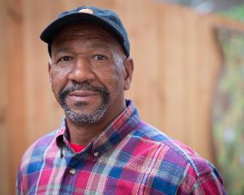
Some of the artist highlights include: Tania Bruguera creating a monument to the “new immigrant,” Mel Chin making a monument for “me and you,” Tyree Guyton tackling opioid addiction and recovery, Sharon Hayes addressing the lack of women in public art, Jamel Shabazz recognizing African American veterans, and Zoe Strauss asking questions about ownership of public space. The complete list of artists is below.
Tyree Guyton, photo by Steve Weinik
for Mural Arts Philadelphia

What makes a monument in the 21st Century? Mural Arts Philadelphia has invited over 20 artists to answer this question for the current city of Philadelphia with an unprecedented series of temporary installations in Philadelphia’s

parks by local and international artists. In addition to the installations, the public art will be accompanied by interactive pop-up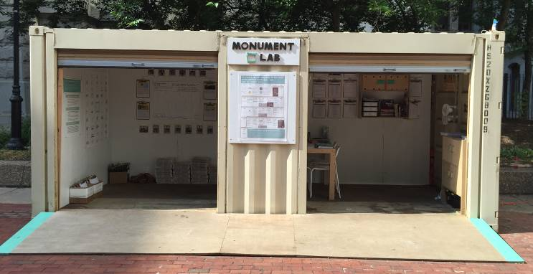 “laboratories” for creative conversations and research collected by youth art guides. During open hours, staff will be present at all labs to distribute information, answer questions, prompt participation, and collect submissions from members of the public. Also, Mural Arts Philadelphia will create a central hub at the Pennsylvania Academy of the Fine Arts, located in the heart of Center City, where all the proposals for Philadelphia monuments of the future, generated around the city during the nine-week project, will be scanned and exhibited, culminating in a new museum of ideas and creative data, built by and for the people. And finally, from panels to parties and tours to talks, there will be public programs creating ways for the community to participate in Monument Lab – plus, each site will host its own weekend event, featuring programming created with the artists and neighborhood partners.

Curatorial team Paul Farber, Ken Lum, and A. Will Brown have selected a group of intellectually, geographically, and culturally diverse artists from Philadelphia and around
the world:
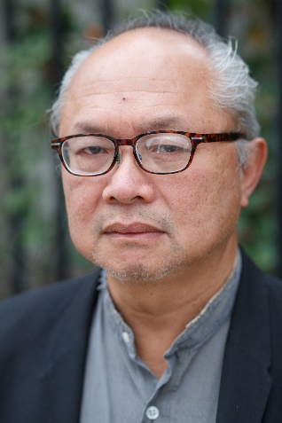
- Tania Bruguera, Havana/New York City/Cambridge
Mel Chin, photo by Steve Weinik
for Mural Arts Philadelphia
- Mel Chin, Egypt, North Carolina
- Kara Crombie, Philadelphia
- Tyree Guyton, Detroit
- Hans Haacke, New York City
- David Hartt, Philadelphia
- Sharon Hayes, Philadelphia
- King Britt and Joshua Mays, Philadelphia and Oakland
- Klip Collective, Philadelphia
- Duane Linklater, North Bay, Ontario
- Emeka Ogboh, Lagos/Berlin
- Karyn Olivier, Philadelphia
- Michelle Angela Ortiz, Philadelphia
- Kaitlin Pomerantz, Philadelphia
- RAIR featuring Abigail DeVille, Philadelphia and New York City
- Alexander Rosenberg, Philadelphia
- Jamel Shabazz, New York City
- Zoe Strauss, Philadelphia
- Hank Willis Thomas, New York City
- Shira Walinsky and Southeast by Southeast, Philadelphia
- Marisa Williamson, New York City

Find more information on each artist here.

Monument Lab projects will be temporary works of public art created in a variety of media including sculpture, performance, projection, sound, and of course, murals. The projects will cover topics such as engagement of public space, equality and social justice, refugee and immigrant issues, opioid addiction and recovery, gentrification and land use, indigenous history, recycling and sustainability, youth voice, Philadelphia music, and neighborhood culture. The complete list of artists’ projects will be announced in the spring.

Monument Lab has evolved from past Mural Arts Philadelphia projects, in elevation of the organization’s mission to change conversations, policies, opportunities, and communities through beautiful public art. Monument Lab will engage diverse artists to explore Philadelphia’s identity through temporary public art projects, a bold update to monument-making aligned to the needs and opportunities of the present day. Through the process it will foster connection, shared understanding, and in some cases healing, through robust public engagement and programs. The sheer scale of the project will contribute to Philadelphia’s reputation for innovation and leadership in public art, attracting audiences from the region, nation, and world.

Jim F. Kenney, Mayor of Philadelphia, stated, “The world-renowned work of Mural Arts Philadelphia continues to put our city in the international spotlight. After more than 30 years, I continue to admire their drive to address social issues through art, and I can’t wait to see what all of the monuments will tell us about our city and the diversity of our public spaces.”

Jane Golden, Executive Director of Mural Arts Philadelphia, said, “Our curators have assembled an inspiring list of artists to come to Philadelphia and express a wide range of visions that reflect on our city’s history and imagine our future. Mural Arts is excited to bring this work to the public and engage everyone in discussing critical issues facing our city today.”

Paul Farber, Monument Lab Artistic Director and Lead Curator, declared, “From Hans Haacke to Zoe Strauss, Hank Willis Thomas to Shira Walinsky and Southeast by Southeast, we are excited to announce an artist roster that seeks a diversity of ideas, identities, and monumental approaches to engaging Philadelphia's history. These artists draw on their own deep connections to the city, and spark reflection on our core values and visions. With temporary monuments and adjacent research labs for public dialogue, our goal is to change the ways we write the history of our city together.”

The projects will be located in and around the original squares of the city as imagined by founder William Penn (City Hall – originally Center Square, Franklin Square, Washington Square, Logan Circle – originally Logan Square, and Rittenhouse Square) as well as five neighborhood parks (Penn Treaty Park, Vernon Park, Norris Square, Malcolm X Park, and Marconi Plaza), plus the exhibition hub space at the Pennsylvania Academy of the Fine Arts. For more information about Mural Arts Philadelphia’s Monument Lab project, visit muralarts.org/monumentlab.

Major support for Monument Lab has been provided by the William Penn Foundation, Tuttleman Family Foundation, Hummingbird Foundation, and the National Endowment for the Arts. The Pew Center for Arts & Heritage has provided major support for projects by Kara Crombie, Kaitlin Pomerantz, Alexander Rosenberg, and Zoe Strauss. The Center also supported a successful 2015 discovery phase led by the curators.

Monument Lab partners include the City of Philadelphia Office of Arts, Culture, and the Creative Economy; Philadelphia Parks and Recreation; and the Penn Institute for Urban Research, with more to be announced.

Mural Arts Philadelphia is the nation’s largest public art program, dedicated to the belief that art ignites change. For over 30 years, Mural Arts has united artists and communities through a collaborative and equitable process, creating nearly 4,000 artworks that have transformed public spaces and individual lives. Mural Arts aims to empower people, stimulate dialogue, and build bridges to understanding with projects that attract artists from Philadelphia and around the world, and programs that focus on youth education, restorative justice, mental health and wellness, and public art and its preservation. Popular mural tours offer a firsthand glimpse into the inspiring stories behind Mural Arts’ iconic and unparalleled collection, which has earned Philadelphia worldwide recognition as the “City of Murals.” For more information, call 215-685-0750 or visit muralarts.org. Follow us on social media: @muralarts on Twitter, Instagram, and Snapchat, MuralArtsPhiladelphia on Facebook, and phillymuralarts on YouTube.
###
EDITOR’S NOTE: More about Monument Lab, including the one-sheet backgrounders on each artist and high-resolution images, are available in the Mural Arts Philadelphia press room at bit.ly/MonumentLabPress.

