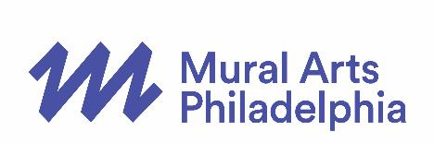
PRESS CONTACT:
Cari Feiler Bender, Relief Communications, LLC
(610) 416-1216, cari@reliefcomm.com

MURAL ARTS PHILADELPHIA
2017 TOURS KICK-OFF WEEKEND

Tweet this: The 2017 @muralarts Tour Season kicks off 4/1 & 4/2 with mini tours & lots of new offerings to see City of Murals www.muralarts.org/tours/

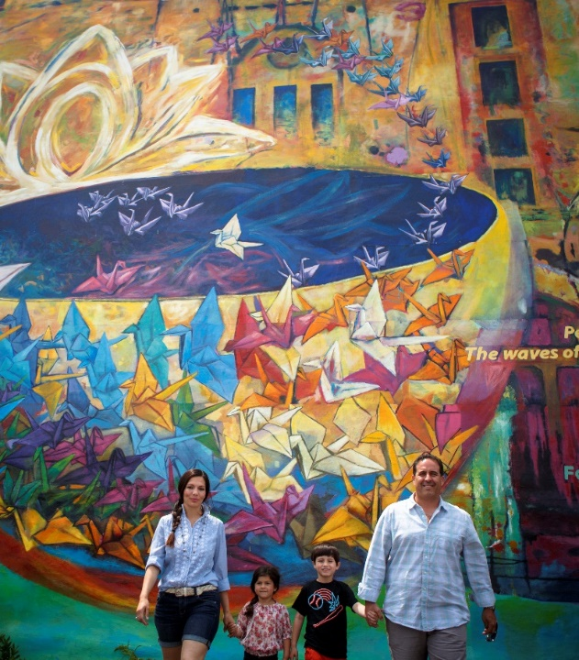
PHILADELPHIA – March 8, 2017 – Mural Arts Philadelphia has created thousands of murals over its more than 30-year history, and each one has a unique story, connecting communities through public art. In 2017, Mural Arts has added new opportunities to hear some of those stories first-hand on several tours that visit a wide swath of neighborhoods across the City of Philadelphia.
Photo by Steve Weinik for Mural Arts Philadelphia

Each year, over 12,000 residents and visitors are guided through a behind-the-scenes look at the vibrant “City of Murals,” with in-depth stories about the people and the communities who inspired and shaped each project. A range of opportunities for regularly scheduled public and private expeditions led by professionally-trained guides are offered from spring to fall.

Kicking off the new 2017 tour season is a special weekend with a few sample tours on Saturday, April 1 and Sunday, April 2, in addition to the opening weekend of the new offerings. A series of mini tours will be presented throughout the weekend with special offers added in celebration. The weekend schedule includes the Masterpieces East Trolley Tour, special North Route and South Route condensed walking tours, the Fishtown Street Art Walk Tour, highlights from Mural Segway Tours and a Mural Mile Center City Walking Tour. All special sample tours require advanced registration.

Kick-Off Weekend Special Tours
On Saturday April 1, guests can enjoy highly acclaimed murals east of Broad Street with the Masterpieces East Trolley Tour. Traveling through North Philadelphia and back into Center City, this excursion provides an in-depth look at Philadelphia’s public art, including stunning works such as the iconic Common Threads by Meg Saligman and Philly Painting project along Germantown Avenue. The tour leaves at 10 a.m. from the Pennsylvania Academy of the Fine Arts, Hamilton Building at 128 N. Broad Street and ends around noon.

Visitors can also join two special North Route and South Route samplings of walking tours on April 1. The shortened version of the North Route goes down Girard Avenue and into Fairmount leaving from the Northwest corner of Broad Street & Fairmount Avenue at 11 a.m., while the South Route allows visitors to experience history and diversity through a sampling of murals from Broad Street into South Philadelphia leaving from the Northwest corner of Broad Street & Tasker Avenue at 1 p.m. Both tours are led by a professionally-trained guide who discusses the stories and artistic processes behind the murals. For these tours, guests can take advantage of a special one-time only buy-one-get-one-free ticket offer. Each tour is $22 per person with a required purchase of at least two tickets at the time of purchase in order to receive the discount. Advanced reservations required.

On Sunday, April 2, visitors can also experience a Fishtown Street Art Walk from 1 - 2:30 p.m. Guided by StreetsDept.com’s Conrad Benner, tour-takers explore the street art of the Fishtown neighborhood, home to the most public art in America. Fishtown is leading the way as Philly’s ever-evolving epicenter for dynamic street art, graffiti, and muralism. Conrad Benner is a photographer and founder of StreetsDept.com, a Philly-based photo-blog that documents and celebrates street art, graffiti, and urban exploration. His blog has been named one of the ‘Best Blogs for Travelers’ by The Guardian and Benner was named ‘Best Art Curator’ in 2014 by Philadelphia Magazine. The cost for this tour is $25 per person and will begin at Frankford Avenue & Richmond Street. Advanced reservations are required

There will also be a regularly scheduled Mural Mile Center City walking tour at 11 a.m. on Sunday, April 2.

Offered both Saturday and Sunday is a condensed Mural Segway Tour through Old City from 3 - 4 p.m. This expedition allows participants to discover the artistry of Mural Arts Philadelphia in an entirely new way by highlighting parts of the traditional Mural Arts Segway Tour. This shortened tour is being offered at a 50% discount ($42.50). This tour begins at the Philly Tour Hub, on 229 Arch Street.

Regular Season Tours
This kick-off weekend is the beginning of regularly-scheduled trolley tours that continue through November and offer unique neighborhood experiences to see Philadelphia’s abundance of murals. The new trolley tour for 2017, the Spring Garden & Beyond Tour, focuses on a variety of new murals and some street art in the Spring Arts District, which skirts Center City. The Masterpieces East & Masterpieces West Tour highlight iconic murals and new works in neighborhoods throughout the city, east and west of Broad Street. In addition to these three trolley routes, Mural Arts Philadelphia also conducts a Journeys South Tour and Philadelphia’s Reimagined Landscapes Tour. All tours rotate throughout the season in order to expose more public art installations to more visitors. Trolleys are enclosed and tours depart rain or shine. A substitute vehicle may be used if necessary. Departs from the Pennsylvania Academy of the Fine Arts, Hamilton Building, 128 N. Broad Street. Prices begin at $32 for adults, $30 for seniors, and $28 for students (with ID) & Youth (3-12). The tours run from April – November on Saturdays from 10 a.m. – Noon and additionally on Fridays from 10 a.m. – Noon from June 23 – August 25.

Walking Tours
Visitors also have the option to set out on foot to tour Philadelphia’s beautiful public art collection with Mural Arts Philadelphia’s Mural Mile Center City Walking Tour. Participants have the chance to view the stunning murals up close and personal as they weave through diverse neighborhoods throughout Center City. With a professionally-trained guide, guests learn about the people, places, and themes of each mural as well as Mural Arts Philadelphia’s 30-year history. New this year, Saturday afternoon tours during the summer months will end at the Uptown Beer Garden at 1735 Market Street and will receive beverage discounts, with a portion of sales donated to Mural Arts Philadelphia. Tours depart from the Pennsylvania Academy of the Fine Arts, Hamilton Building, 128 N. Broad Street on Saturdays at 11 a.m. & 4 p.m. and Sundays at 11 a.m. from April – November. From the middle of June – the middle of August on Wednesdays at 11 a.m. & 4 p.m., tour departs from Philly Tour Hub at 219 Arch Street. Price is $22 per person.

Train Tours
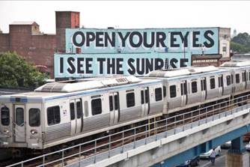
Participants can also enjoy Mural Arts Philadelphia’s Mural Arts Love Letter Train Tour. In collaboration with Mural Arts Philadelphia, New York-based artist Stephen Powers created Love Letter, a public art project consisting of a series of 50 rooftop murals from 45th to 63rd streets along the Market Street corridor in West Philadelphia. Professionally-trained guides provide commentary and lead passengers on and off trains to spot murals from platforms. These train tours depart from the Pennsylvania Academy of the Fine Arts, Hamilton Building, 128 N. Broad Street on Saturdays from 10:30 a.m. – Noon and Sundays from 1-2:30 p.m. from January – Memorial Day and Labor Day – December. Price is $22 per person, including a SEPTA token. SEPTA pass holders will receive a $2 discount on Lover Letter tours by using the discount code SEPTA. Advanced ticket sales only.
Photo by Adam Wallacavage for Mural Arts Philadelphia

Other Tours
A Mural Arts Segway Tour will continue to be offered this year, daily at 9:30 am. Leaving from Philly Tour Hub, travel through Spring Garden and Northern Liberties and learn about the spectacular murals while riding a unique Segway. Cost is $85 per person. For further details or to purchase tickets visit: http://www.phillytourhub.com/Our-Tours/Segway-Tours/2-Hour-Mural-Tour.aspx

Mural Arts Philadelphia has teamed up with Philadelphia’s Magic Gardens to create an afternoon of Murals to Mosaics. The guided tour begins on foot walking along South Street and Queen Village and ends with a self-guided visit to Philadelphia’s Magic Gardens, 1020 South Street. Tours will begin at Philadelphia Arts Bank, 601 S. Broad Street. The tour is only offered the last Sunday of each month from June – September from 1 PM – 3 PM. The cost is $25 dollars per person, which includes the admission to Philadelphia’s Magic Gardens. Advance registration is required.
All public tour offerings are available for private bookings for social, business, or civic groups of any size and ages. A step-on option is also available for groups with their own vehicle. Other activities include an Experiential Mural Painting activity and a Mural Arts Scavenger Hunt for private groups, both of which can be combined with a tour. For flat-rate pricing, further details, or to book private tours and activities, call 215-925-3633.

Advanced reservations are STRONGLY recommended, as tours frequently sell out. Tickets are available online at muralarts.org/tours or by phone at 215-925-3633.

Mural Arts Philadelphia is the nation’s largest public art program, dedicated to the belief that art ignites change. For over 30 years, Mural Arts has united artists and communities through a collaborative and equitable process, creating nearly 4,000 artworks that have transformed public spaces and individual lives. Mural Arts aims to empower people, stimulate dialogue, and build bridges to understanding with projects that attract artists from Philadelphia and around the world, and programs that focus on youth education, restorative justice, mental health and wellness, and public art and its preservation. Popular mural tours offer a firsthand glimpse into the inspiring stories behind Mural Arts’ iconic and unparalleled collection, which has earned Philadelphia worldwide recognition as the “City of Murals.” For more information, call 215-685-0750 or visit muralarts.org. Follow us on social media: @muralarts on Twitter, Instagram, and Snapchat, MuralArtsPhiladelphia on Facebook, and phillymuralarts on YouTube.
###

EDITOR’S NOTE:
High-resolution photographs are available for media usage at: http://bit.ly/MuralArtsTours
Email cari@reliefcomm.com with any questions.

